Home page
After Home Tab add one more Tab - About KLE
Under About KLE add below mentioned sub tabs
- History
- Emblem
- Vision and Mission
- Founders
- Board of Management
- Chairman’s Message

About KLE

Learning is an exciting journey, guided by dedicated educators who bring knowledge to life — and this belief has shaped KLE since the very beginning. Founded in 1916 in Belagavi by seven visionary teachers known as the "Saptarishis," KLE Society was born from a simple but powerful conviction: that education was the surest path to a community's material, intellectual, and spiritual growth. What began as a single Anglo-Vernacular School has, over more than a century, grown into one of India's most respected educational institutions, spanning schools, colleges, and universities across disciplines as varied as medicine, engineering, dentistry, nursing, agriculture, and business.

For over 40 years, KLE has flourished under the leadership of Dr. Prabhakar Kore, whose vision has carried the institution from a regional network of colleges into a globally recognized center of learning, healthcare, and research. Under his guidance, KLE has continually expanded its reach — establishing its own university for health sciences, elevating its flagship engineering college to university status, and building a network of hospitals that serve hundreds of thousands of patients each year.

KLE's global standing has been further elevated through collaborations with universities in the US, UK, and Malaysia, bringing international perspectives and opportunities to its students while opening doors for cross-border research and exchange. These partnerships reflect KLE's commitment to staying connected with the best educational practices from around the world, even as it stays rooted in the values of its founders.
Today, KLE is home to more than 1,48,000 students and over 18,000 faculty and staff, a testament to the scale and trust the institution has built over the decades. From its humble beginnings in a rented bungalow in Belagavi to its present-day standing as a globally renowned educational institution, KLE's journey remains guided by the same founding spirit: that education, delivered with dedication and care, has the power to transform lives.

History
We are a Globally recognised Health Sciences University, founded in 1916, advancing innovation, research, and excellence.
KLE Society fosters education, research, and healthcare, empowering individuals to succeed and contribute as responsible citizens.
The KLE Society, a renowned charitable trust, is guided by a strong and visionary Board of Management that upholds its legacy of service and excellence. Elected every five years through a democratic process, the board reflects transparency, accountability, and collective responsibility. With leaders drawn from diverse professional backgrounds, the management ensures that the Society’s vast network of institutions is managed with efficiency, Vision, and integrity. Operating in a structured and professional manner, the Board of Management not only Upholds the Society’s values but also drives its growth, ensuring quality education and social service keeping at the heart of its mission.
Learning is an exciting journey, guided by dedicated educators who bring knowledge to life. Collaborations with universities in the US, UK, and Malaysia have further elevated KLE’s global standing. Under Dr.Prabhakar Kore’s leadership for over 40 years, KLE has flourished, supported by 1,48,000+ students, and 18,000 faculty, establishing itself as a globally renowned educational institution.

Emblem
 | The emblem that the Karnataka Lingayat Education Society has officially adopted is carefully designed, beautifully carved, meaningful, and symbolic of the ideology that the K.L.E. Society stands for. It truly reflects the aims, objectives, and aspirations of the Society. .  The 'Sacred Bull' is symbolic of 'service'; The 'Flying Bird' is the awakened youth to take up any challenge; The 'Hexagon of Veerashaiva Dharma' with its secular outlook in service of the people; The 'Ishtalinga' in a palm and the Halo around it is suggestive of knowledge to remove ignorance of the people in fulfillment of the Veerashaiva philosophy .  Therefore, the idea of the Emblem is that, by the union of Dharma, Knowledge, Service and Sacrifice, the vision of the KLE Society which is giving excellent educational service to the people of all castes, creeds, religions and regions is totally obtained.

Vision and Mission

Vision

To continually evolve as an organisation symbolising global excellence in standards and commitments in the domains of quality education, healthcare, and research, while at the same time adopting, nurturing, and propagating democratic values, charitable virtues, and a philanthropic culture.

Mission
To propagate, support, and champion the cause of “Excellence through Education” for aspirants across the globe.
To recruit and groom well-qualified, well-trained, and efficient human resources committed to the accomplishment of individual and organizational excellence through continual learning.
To create infrastructure and state-of-the-art educational facilities and provide opportunities for school, collegiate, technical, and professional education, especially for students in rural India.
To provide state-of-the-art healthcare facilities and services to people in both urban and rural areas.
To contribute to the welfare of the farming community in urban and rural areas by facilitating education, the adoption of technology, and modern farming and farm management practices.
To set, develop, and maintain high standards for quality education in existing KLE institutions through ‘best-in-domain’ work systems and methods.
To constantly display sensitivity and respond to changing educational, social, and community demands.
To supplement conventional education with real-time exposure and experiential learning and groom technically well-versed, morally committed, and ethically strong professionals.
To develop an entrepreneurial ecosystem that nurtures creativity and innovation and to integrate the same with existing professional academic courses in order to promote regional enterprise as a precursor to economic development.
To facilitate the landscaping of the learning environment to enable “21st Century Learning” and to maintain clean and green campuses with a pollution-free environment and eco-friendly surroundings.
To undertake the development of society at large and motivate individuals to be socially responsible, productive, and useful citizens of the globalised world.
To impart the spirit of inquiry, promote scientific temperament, and encourage research with the aid of state-of-the-art equipment, methods, and infrastructure as an essential part of professional learning in basic sciences, healthcare, engineering, creative arts and humanities, management, and commerce.

Founders

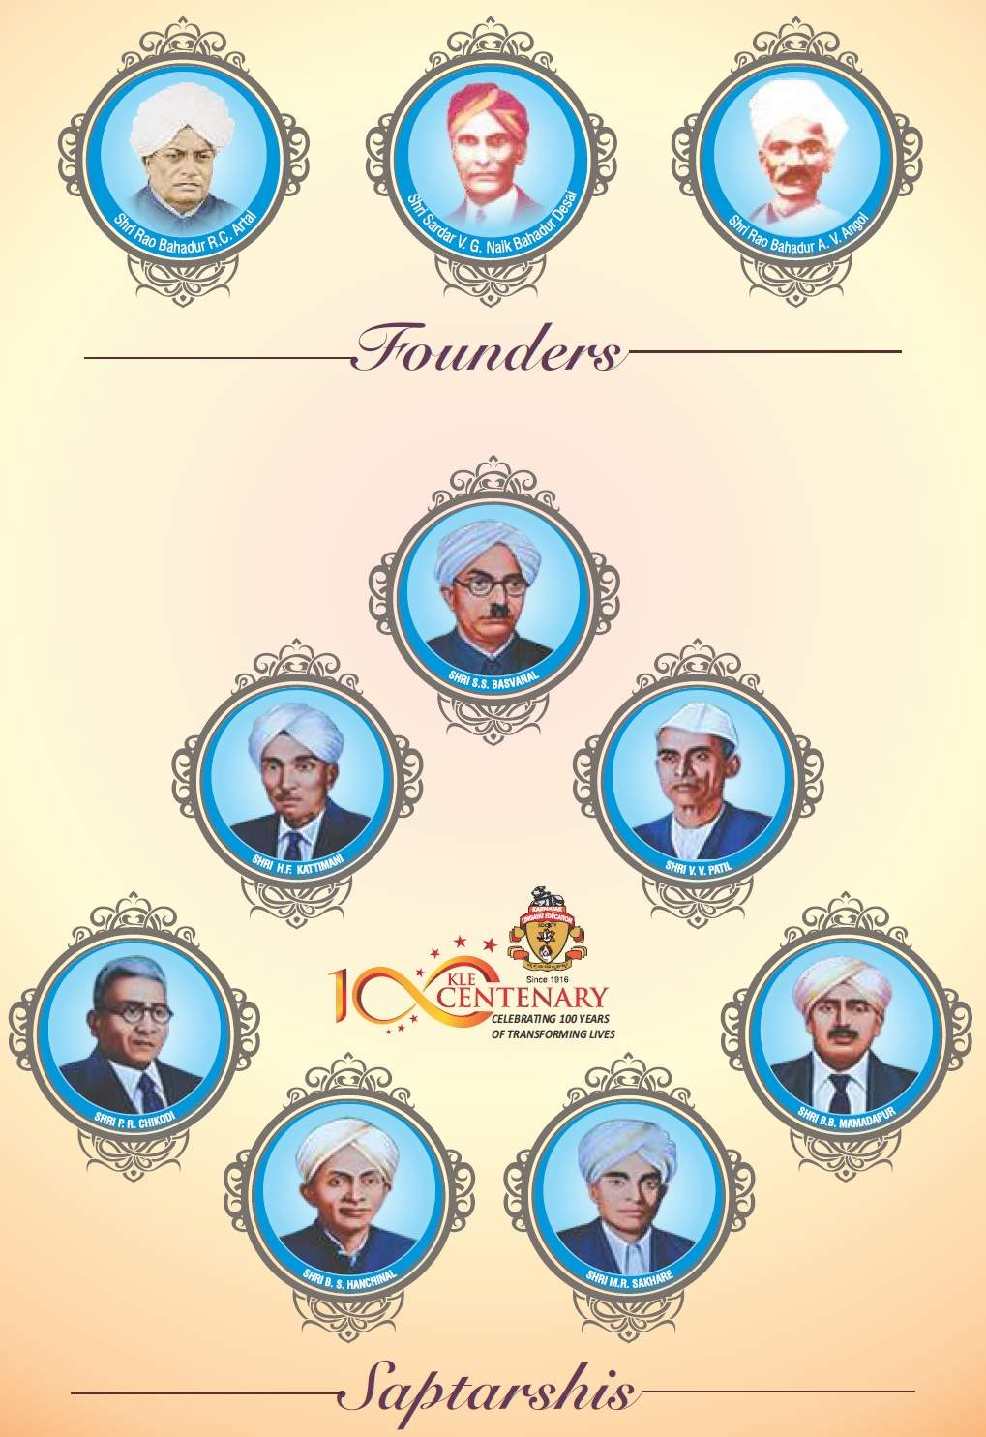

Board Of Management

Office Bearer

President

Shri M. S. Koujalgi

Vice-President

Shri Basavaraj S. Tatawati

MEMBERS OF THE BOARD OF MANAGEMENT

SI.No | Member Name | Designation
1. | Shri Amit P. Kore | Chairman
2. | Shri Y. S. Patil | Member
3. | Shri Mahantesh M. Kavatagimath | Member
4. | Shri Anil V. Patted | Member
5. | Shri Jayanand M. Munavalli | Member
6. | Shri Basavaraj R. Patil | Member
7. | Shri Mallikarjun C.Kolli | Member
8. | Dr. Vishwanath I. Patil | Member
9. | Shri Praveen A. Bagewadi | Member
10. | Dr. Preeti K. Doddwad | Member
11. | Shri Manjunath S Munavalli | Member
12. | Shri Vijay S.Metgud | Member

 | Nominated Life Members
13. | Dr. Deepa C.Metgud | Member
14. | Shri Bharamappa S.Ambi | Member
15. | Shri Sheetal G.Nanjappanavar | Member
16 | Dr. Sunil S. Jalalpure | Secretary
17. | Dr. Prakash R. Kadakol | Joint-Secretary

Chairman
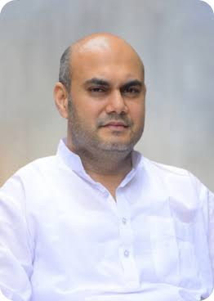
Shri Amit Prabhakar Kore
Chairman, KLE Society, Belagavi | Entrepreneur | Institution Builder
MBA (Finance), University of Illinois, Chicago • B.E., Mechanical Engineering
Amit Prabhakar Kore has built his career at the intersection of institutional governance and industrial enterprise. Educated in engineering and finance in the United States and shaped by over two decades of hands-on leadership across healthcare, education, and industry, he brings a clear-eyed global perspective to the organisations he leads — whether in the boardroom of one of India's largest educational and healthcare societies or at the helm of his corporate ventures.
What sets him apart is the ability to work at both ends simultaneously: setting institutional direction while staying engaged with the operational, community, and social dimensions of each venture. His record is measured not in titles, but in institutions built, industries scaled, and the improved quality of life in the communities his work has touched.
As Chairman of KLE Society, he continues the institution's century-long legacy of transforming lives through education, healthcare, and research — building on the foundation laid by Dr. Prabhakar Kore's leadership over more than four decades.

Honorary Chairman,
Dr. Prabhakar Basavaprabhu Kore
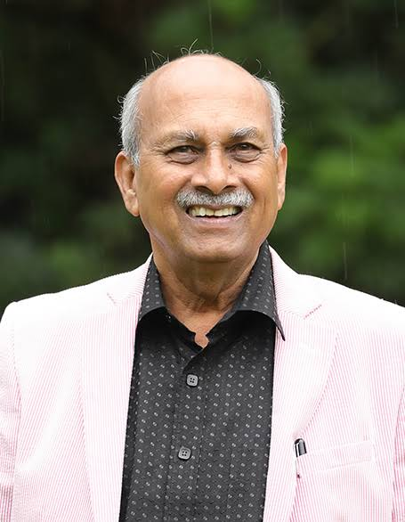
Honorary Chairman, KLE Society, Belagavi

Padma Shri Awardee • Former Member of Parliament, Rajya Sabha
Born on 1st August 1947 in the small village of Ankali, Chikodi Taluka, Dr. Prabhakar Kore rose from humble, agrarian roots to become one of India's most influential institution builders. He took over the leadership of KLE Society in 1985, when it comprised barely a few dozen institutions, and over the next four decades grew it into a network of more than 300 institutions spanning education, healthcare, agriculture, and community welfare across Karnataka and Maharashtra.
Under his stewardship, KLE established the KLE Academy of Higher Education and Research (KAHER) in 2006 and KLE Technological University in 2015, alongside a large healthcare network anchored by the multi-specialty Dr. Prabhakar Kore Hospital and Medical Research Centre. He also served three terms as a Member of the Rajya Sabha and held several honorary doctorates from universities in India, Malaysia, and the United States.
In January 2026, Dr. Kore was conferred the Padma Shri — one of India's highest civilian honours — by the Government of India, in recognition of his contributions to education, literature, and rural development. Reflecting on the honour, he attributed it to the collective effort of the KLE family and the farming communities who supported him throughout his journey. Today, as Honorary Chairman, Dr. Kore's legacy continues to guide KLE's mission of transforming lives through education, healthcare, and research.

About College Tab
Principal message in available next page
Principal's Message (Add photo along with message)
Dear Students, Parents, and Well-Wishers,
It gives me immense pleasure to welcome you to KLE Society's SCP Arts, Science and D. D. Shirol Commerce College, Mahalingpur, a premier institution committed to providing quality higher education since its establishment in 1987. Guided by the noble vision of the KLE Society, our college has consistently strived to nurture knowledge, character, and excellence while preparing students to meet the challenges of an ever-evolving global society.
In today's rapidly changing world, education extends far beyond the boundaries of classrooms. Technological advancements, globalization, and the knowledge-driven economy demand graduates who are academically competent, professionally skilled, socially responsible, and ethically grounded. At our institution, we are dedicated to creating an environment that fosters critical thinking, innovation, creativity, and lifelong learning.
Our college offers a wide range of undergraduate and postgraduate programmes, including B.A., B.Com., B.Sc., B.C.A., and M.Com., catering to the diverse aspirations of students. We are proud to share that, from the Academic Year 2026–27, the college has introduced Bachelor of Business Administration (B.B.A.) and the Integrated Teacher Education Programme (ITEP), further expanding opportunities for students to pursue quality education aligned with contemporary academic and professional requirements.
Affiliated with Bagalkot University, our institution is committed to maintaining high academic standards through an experienced and dedicated faculty, modern learning resources, well-equipped laboratories, digital facilities, and a vibrant campus environment. Alongside academic excellence, we emphasize co-curricular and extracurricular activities, leadership development, community engagement, cultural enrichment, and sports to ensure the holistic development of every student.
At KLE Society's SCP Arts, Science and D. D. Shirol Commerce College, we believe that education is a transformative journey that empowers individuals to become responsible citizens, compassionate human beings, and capable professionals. Our mission is to nurture confidence, integrity, discipline, and a spirit of service, enabling our students to contribute meaningfully to society and the nation.
I warmly invite aspiring students to become a part of our academic community and experience an atmosphere of learning, innovation, and personal growth. Together, let us continue our pursuit of knowledge, excellence, and values, shaping a brighter future for ourselves and for society.
I wish all our students every success in their academic journey and future endeavors.
With best wishes,
Principal
Shri. N. B. patil
KLE Society's SCP Arts, Science and D. D. Shirol Commerce College
Mahalingpur
Teaching Staff UG
Sl. No | Name | Department | Designation
1 | Shri N. B. Patil | Commerce | Principal
2 | Dr.S.D.Soraganvi | Economics & Agricultural Marketing | Associate Professor
3 | Shri.A.M.Ugare | Political Science | Lecturer
4 | Smt. J.R.Patil | Chemistry | Lecturer
5 | Shri C.M.Aigali | English | Lecturer
6 | Dr.S.S.Koli | Kannada | Lecturer
7 | Miss S T Diwanji | Mathematics | Lecturer
8 | Miss. C M Gennur | Zoology | Lecturer
9 | Shri T D Dangi | History | Lecturer
10 | Smt D A Naik | Chemistry | Lecturer
11 | Shri.P.M.Gouli | Hindi | Lecturer
12 | Shri.S.S.Mugalyal | Botany | Lecturer
13 | Shri.I.C.Shirol | Kannada | Lecturer
14 | Smt.R.M.Kakade | Commerce | Lecturer
15 | Dr.S.C.Bijjaragi | Zoology | Lecturer
16 | Shri.K. S. Patil | English | Lecturer
17 | Shri. R.V.Chougala | Journalism & Mass Communication | Lecturer
18 | Smt.S.I.Hosurmath | Economics | Lecturer
19 | Shri.S.I.Patil | Bachelor of Computer Application | Lecturer
20 | Miss.P.S.Managanvi | Commerce | Lecturer
21 | Shri.M.B.Dharigoudra | Commerce | Lecturer
22 | Shri.A.R.Urabi | Bachelor of Computer Application | Lecturer
23 | Shri.P.T.Athani | English | Lecturer
24 | Shri P.S.Hipparagi | Physical Education | Lecturer
25 | Smt P M Mutnali | Sociology | Lecturer
26 | Shri. V T Badiger | Bachelor of Computer Application | Lecturer
27 | Ms.S S Kamagond | Bachelor of Computer Application | Lecturer
28 | Shri S A Patil | Physics | Lecturer
29 | Ms. A I Latti | Commerce | Lecturer
30 | Ms. S A Savadi | Physics | Lecturer
31 | Ms. D.A.Ammanagi | Bachelor of Computer Application | Lecturer
32 | Smt. Akshataka Hanamangond | Bachelor of Computer Application | Lecturer
33 | Ms. J.S.Horatti | Kannada | Lecturer
34 | Smt. S. M. Kalamalgi | Bachelor of Computer Application | Lecturer
35 | Shri. Y. M. Dyamannavar | Political Science | Lecturer
36 | Shri. N. L. Hipparagi | History | Lecturer
37 | Ms. A. V. Kulakarni | Chemistry | Lecturer (Part time)
38 | Shri. Shirish Halemani | BBA | Lecturer
39 | Shri. R. M. Uppara | Bachelor of Computer Application | Lecturer
40 | Ms. R. M. Bandigani | Bachelor of Computer Application | Lecturer
41 | Ms. A. B. Kadahatti | BBA | Lecturer
Teaching Staff PG
Sl. No | Name | Department | Designation
1 | Smt. G. G. Madarakhandi | PG Dept. of Commerce | Lecturer
2 | Ms. L. S. Hadapad | PG Dept. of Commerce | Lecturer
Library Staff
Sl. No | Name | Department | Designation
1 | Shri. P. B. Jabashetti | Library | Assistant Library
Non Teaching Staff
Sl. No | Name | Department | Designation
1 | Shri.M. B. Patil | Academic Office | Office Suprientendent
2 | Shri.D. S. Kumbar | Academic Office | SDA/Typist
4 | Smt. R D Bhosale | Academic Office | FDA
5 | Shri R.S.Jatti | Academic Office | Accountant
6 | Shri. B. M. Bandi | Academic Office | SDA
6 | Shri K.S.Jadar | Bachelor of Computer Application | Lab Instructor
7 | Smt. S. N. Galagali | Bachelor of Computer Application | Office Assistant
8 | Shri. B. D. Konnur | Bachelor of Computer Application | Asst.Accountant
8 | Shri.D. S. Aneppagol | Academic Office | Attender

Menial Staff
Sl. No | Name | Sl.No | Name
1. | Shri. P.M. Kanti | 4. | Shri. Bhimappa
2. | Smt. C. K. Kamat | 5. | Shri. S. R. Sagari
3. | Smt. R. S. Dombar | 6. | Shril. H. S. Davaskar

